SouthWest University
School of Computer and Information Science

Program: Computer Science and Technology
Couse Title: C Programming
Chapter Title:
Unit No:
Assignment No.:

Issue Date:

Submission Deadline:

Assessor/Tutor:

Student: 蔡前哲

Student’s Reg. No: 222021321102065

NOTES TO STUDENTS
- Check carefully the submission date and the instructions given with the assignment. Late assignments will not be accepted.
- If you are unable to hand in your assignment on time and have valid reasons such as illness, you may apply (in writing) for an extension.
- If you are caught plagiarizing, you could have your grade reduced to zero, or at worst, you could be excluded from the course.
- Your submission document should include screen shots of VC++ showing your code and the output results of running your code.
- Complete your assignment in Word document and submit it to FTP server
- Your file name should start with your Reg. No, and then include your name, and assignment NO. for example “222012321062259_李丹_assignment1.docx”. Remember to link different fields together using the underscore character (_).

Formatting Concerns
#1: You should have a header that explains the program
#2: There should be a space between the prompt and the place where you type in the value.
#3: Your work should be formatted nicely as in the sample output.

STUDENT’S DECLARATION:

I confirm that this is all my own work.

Student Signature:

Assignment Description
Scenario and Tasks：

Practice on chapter 4 Beginning Decision Making and Looping

- 4.1 Suppose that a,b and c are coefficients of a quadratic equation (ax^2+bx+c=0),the values of the variables are input by keyboard. Write a program to calculate the roots of a quadratic equation and write to the screen.

Solution:

Code:
#include<stdio.h>
#include<math.h>

int main()
{
int a,b,c;
scanf("%d%d%d",&a,&b,&c);
int delta;
delta = b*b-4*a*c;

double x1,x2;
x1 = (-b+double(sqrt(delta)))/double(2*a);
x2 = (-b-double(sqrt(delta)))/double(2*a);
if(delta < 0) printf("´Ë·½³ÌÎÞ½â");
else if(delta == 0) printf("·½³ÌµÄ¸ùÎª0");
else printf("·½³ÌµÄÁ½¸ö¸ù·Ö±ðÎª\n%lf\n%lf",x1,x2);

return 0;
}

Screen Capture of The Code:
代码图：
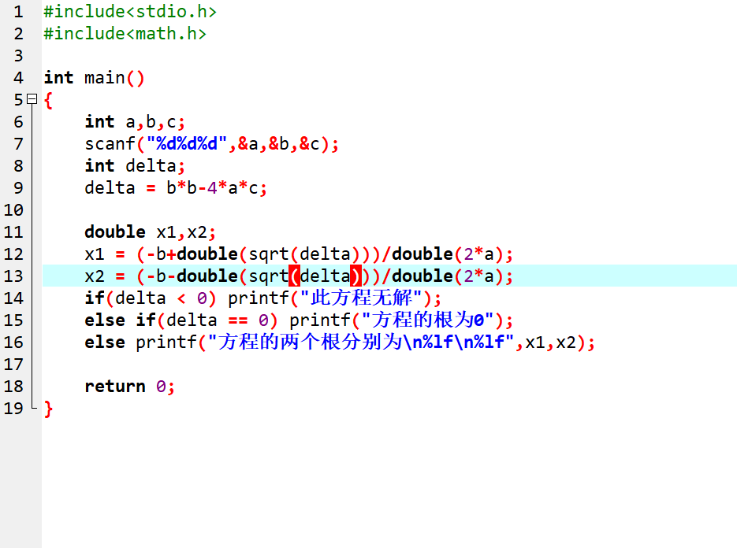
运行图：
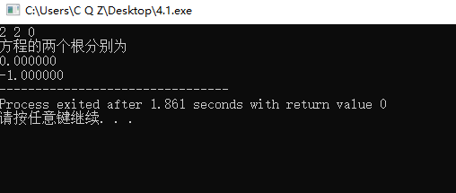

- 4.2Write a program to judge the Leap year.
Input any year of the year, write a program to determine if the year is a leap year or not?
Can be divisible by 4, but can not be divisible by 100.
Can be divisible by 400.
Solution1: if else
Solution 2: logical expression

Solution:

Code:

Screen Capture of The Code:
代码图：
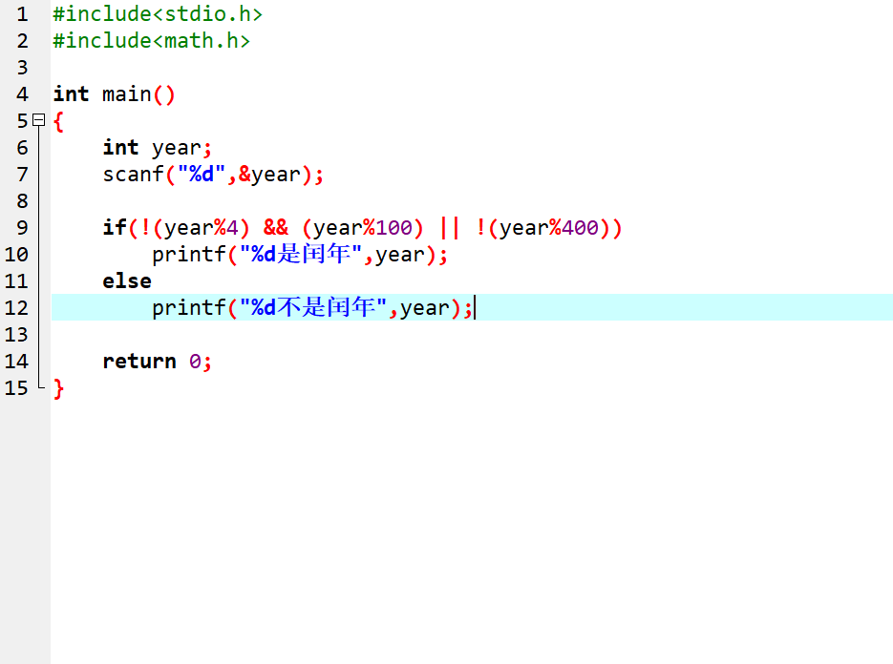
运行图：
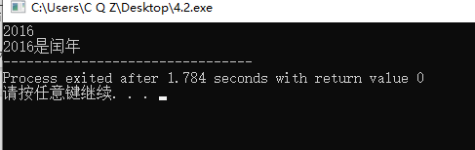
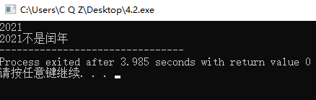

4.3The grade structure for a class as follows:
90-100 A
80-89 B
70-79 C
60-69 D
<60 F
(IF-ELSE ,SWITCH)
Solution:

Code:
#include<stdio.h>
#include<math.h>

int main()
{
FILE *fp, *fp2;
fp = fopen("GRADE.in","r");
fp2 = fopen("GRADE.out","w");

for(int i = 1; i <= 10; i++)
{
int score;
fscanf(fp,"%d",&score);
{
if(score < 60) fprintf(fp2,"%d F\n",score);
else if(60 <= score && score <= 69) fprintf(fp2,"%d D\n",score);
else if(70 <= score && score <= 79) fprintf(fp2,"%d C\n",score);
else if(80 <= score && score <= 89) fprintf(fp2,"%d B\n",score);
else if(90 <= score && score <= 100) fprintf(fp2,"%d A\n",score);
}
}

return 0;
}

Screen Capture of The Code:
代码图：
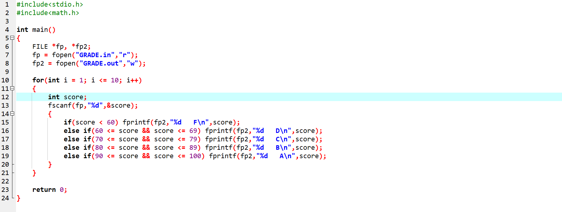

运行图：
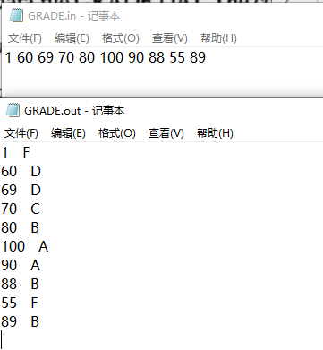

4.4

Solution:

Code:

#include<stdio.h>
#include<math.h>

char mon[13][10]={"","January","February","March","April","May","June","July","August","September","October","November","December"};
int month, day;
int ans;

int cal(int m)
{
switch(m)
{
case 1:
return 31;
break;
case 2:
return 28; //I don't know what year the title was asked for.
//So I calculated by 2022. It's not a leap year.
break;
case 3:
return 31;
break;
case 4:
return 30;
break;
case 5:
return 31;
break;
case 6:
return 30;
break;
case 7:
return 31;
break;
case 8:
return 31;
break;
case 9:
return 30;
break;
case 10:
return 31;
break;
case 11:
return 30;
break;
case 12:
return 31;
break;
}
}

int change()
{
int num = 0;
for(int i = 1; i < month; i++)
num += cal(i); //计算i月有多少天
num += day;
return (num-1);
}

int main()
{
int n;
FILE *fp,*fp2;
fp = fopen("days.in","r");
fp2 = fopen("days.out","w");

fscanf(fp,"%d",&n);
for(int i = 1; i <= n; i++)
{
fscanf(fp,"%d%d",&month,&day);
ans = change();
fprintf(fp2,"%-3d %-10s",day,&mon[month][0]);
fprintf(fp2,"距1月1日有%d天\n",ans);
}

return 0;
}

Screen Capture of The Code:
代码图：
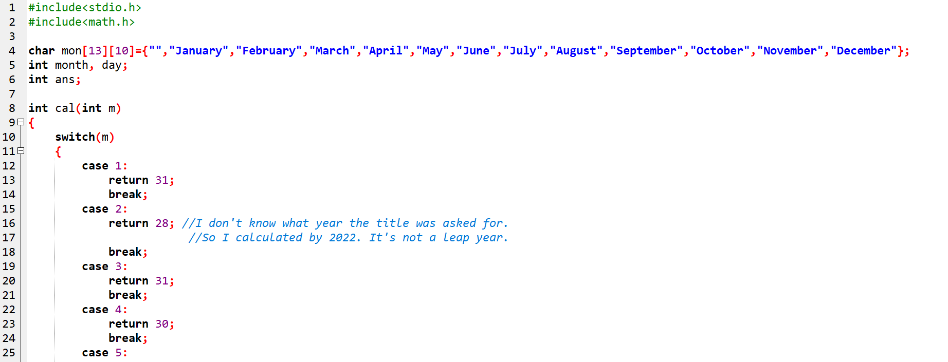
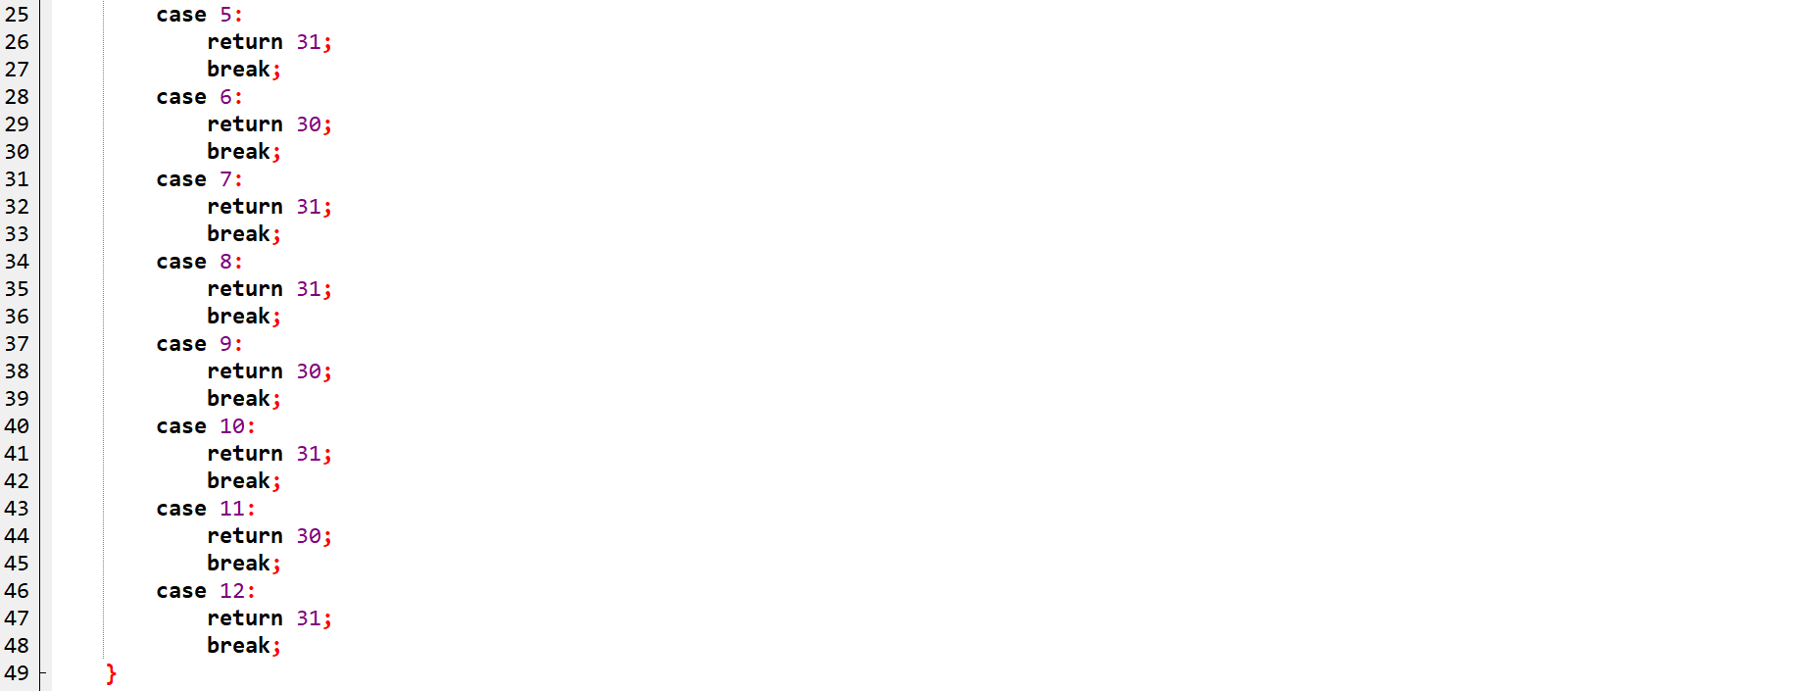
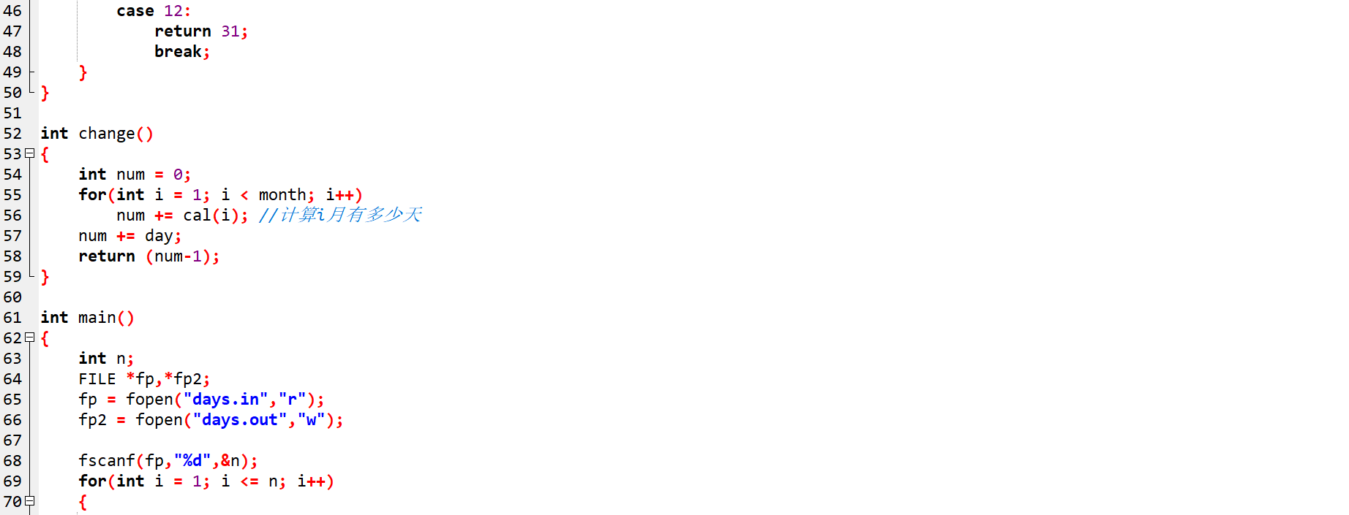
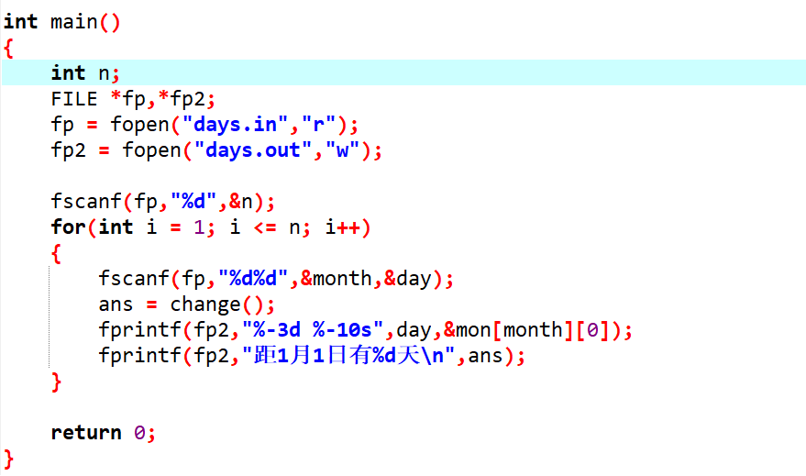

运行图：
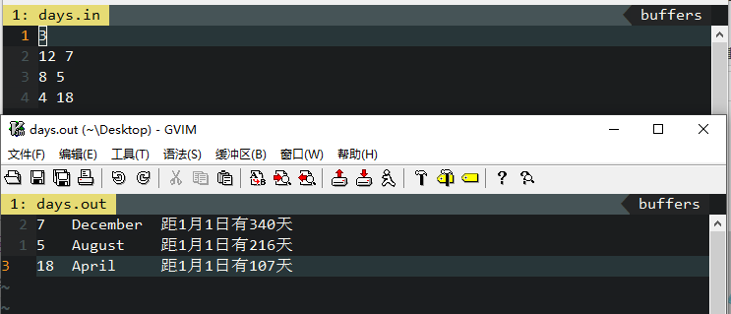

- 4.5 Contracts and other legal documents are often dated in the following way:
Dated this __________ day of __________ , 20__ .
Write a program(switch) to display a date in this form after the user enters the date in month/day/year form:
Enter date (mm/dd/yy): 7/19/14
Dated this 19th day of July, 2014.
Solution:

Code:
#include<stdio.h>
#include<math.h>
char mon[13][10]={"","January","February","March","April","May","June","July","August","September","October","November","December"};
int main()
{
int m,d,y;
scanf("%d/%d/%d",&m,&d,&y);
printf("Dated this ");
switch(d)
{
case(1):
printf("%dst",d);
break;
case(2):
printf("%dnd",d);
break;
case(3):
printf("%drd",d);
break;
default:
printf("%dth",d);
}

printf(" day of %s, 20%d.",&mon[m][0],y);

return 0;
}

Screen Capture of The Code:
代码图：
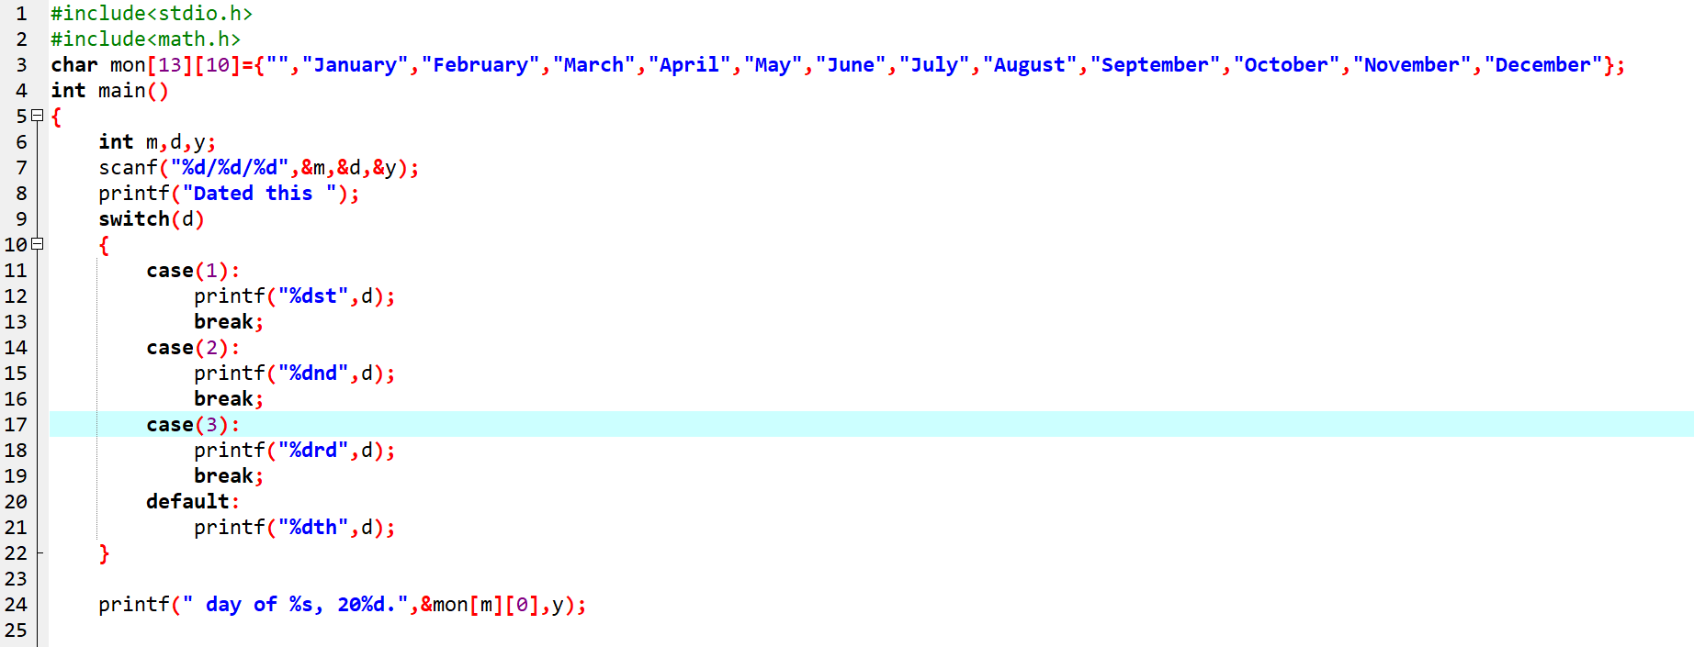
运行图：
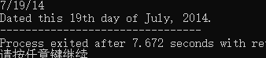
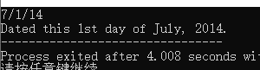

4.6 Use if and other C statement to determine if a given integer N is a Prime number or not。
Solution:

Code:
#include<stdio.h>

int main()
{
int n;
bool f = 1;

scanf("%d",&n);
if(n == 1) f = 0;
else
for(int i = 2; i*i <= n; i++ )
if(n%i == 0) f = 0;

if(f) printf("%d是素数",n);
else printf("%d不是素数",n);

return 0;
}

Screen Capture of The Code:
代码图：
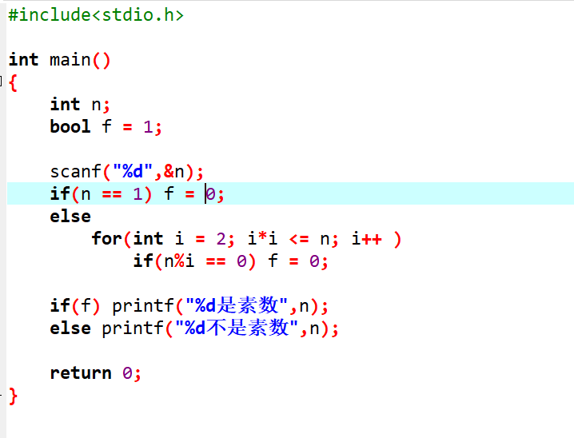
运行图：
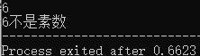

4.7Write a program to calculate the value of π using the following formula.
1-1/3+1/5-1/7+……=π/4

Code:
#include<stdio.h>

int main()
{
double pi = 0;
double sum = 0;

for(int i = 3; i <= 1000000; i+=4)
sum -= double(1.0/double(i));
for(int i = 1; i <= 1000000; i+=4)
sum += double(1.0/double(i));
pi = 4*sum;

printf("%lf", pi);
return 0;
}

Screen Capture of The Code:
代码图：
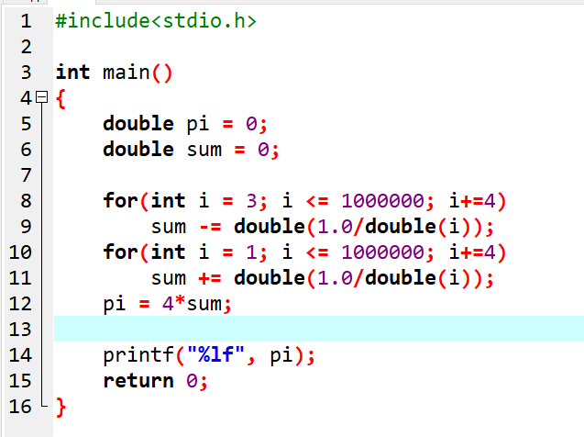
运行图：
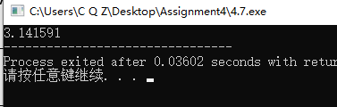

4.8 Write a program to calculate the first 40 numbers of the Fibonacci sequence:
F1=1,F2=1(n=1,2)
Fn=Fn-1+Fn-2(n>=3)

Code:
#include<stdio.h>

int fib[100];

int main()
{
fib[1] = 1;
fib[2] = 1;
for(int i = 3; i <= 40; i++)
fib[i] = fib[i-1]+fib[i-2];

for(int i = 1; i <= 40; i++)
{
printf("%d ",fib[i]);
if(i%10 == 0) printf("\n");
}

return 0;
}

Screen Capture of The Code:
代码图：
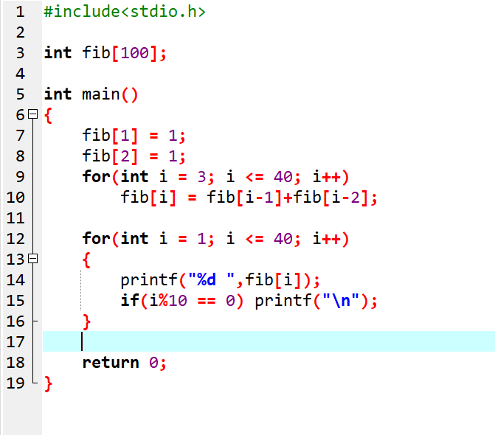
运行图：
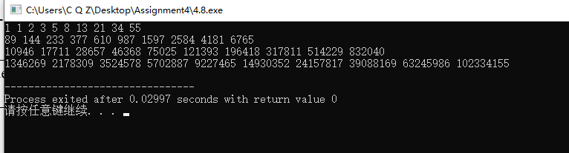

4.9

Code:
#include<stdio.h>

int main()
{
int maxx = -0x7fffffff, maxx2, minn = 0x7fffffff, minn2;
FILE *fp;
fp = fopen("TWOMM.in","r");

for(int i = 1; i <= 20; i++)
{
int t;
fscanf(fp,"%d",&t);
if(t > maxx)
{
maxx2 = maxx; maxx = t;
}
if(t < minn)
{
minn2 = minn; minn = t;
}
}

printf("The two largest: %d %d\n", maxx, maxx2);
printf("The two largest: %d %d", minn, minn2);

return 0;
}

Screen Capture of The Code:
代码图：
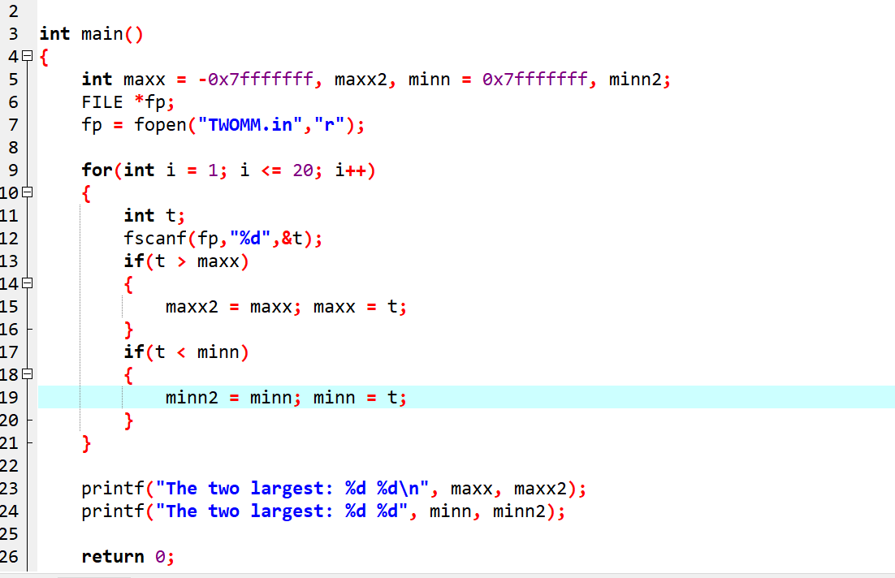
运行图：
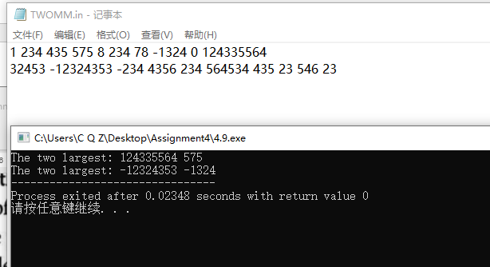

4.10 Print the figure as flows
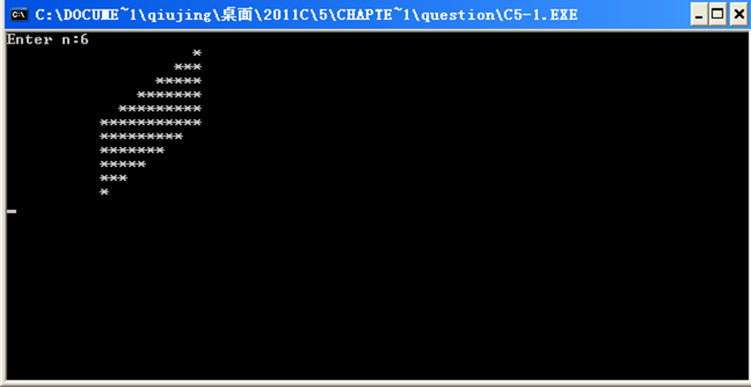

Code:
#include<stdio.h>

/*
每行 2i-1 个 *
前n行 先输出2n-1-(2i-1)=2(n-i)个空格 2i-1个 *
(第n行 2n-1 个 * 0个空格)
n+1...2n-1行 与2n-i行个数一样 输出顺序相反
n-(2n-i)=i-n
*/

int main()
{
int n;
scanf("%d",&n);
for(int i = 1; i <= 2*n-1; i++)
{
if(i <= n)
{
for(int j = 1; j <= 2*(n-i); j++)
printf(" ");
for(int j = 1; j <= 2*i-1; j++)
printf("*");
}
else
{
for(int j = 1; j <= 2*(2*n-i)-1; j++)
printf("*");
for(int j = 1; j <= 2*(i-n); j++)
printf(" ");
}
printf("\n");
}
}

Screen Capture of The Code:
代码图：
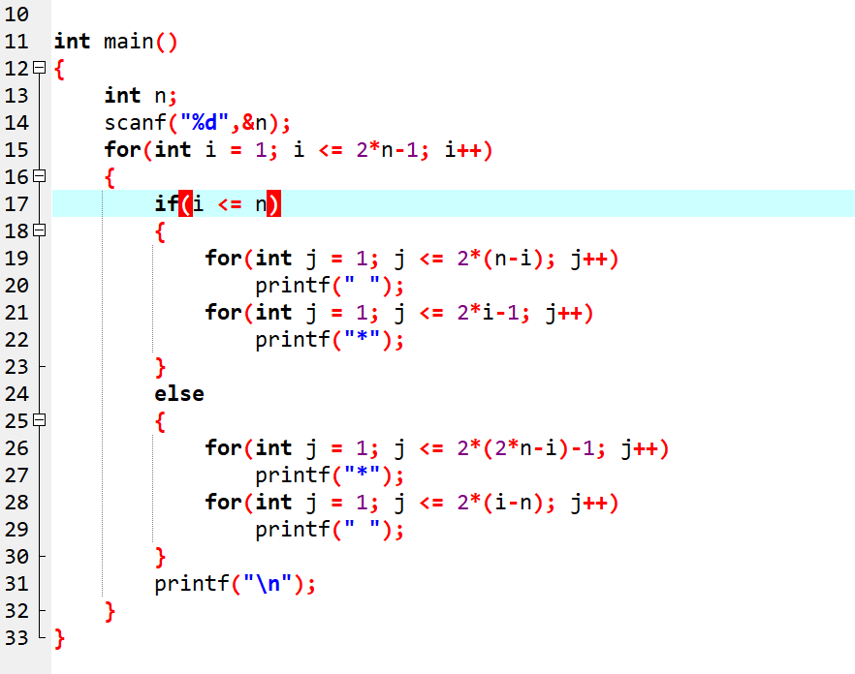
运行图：
